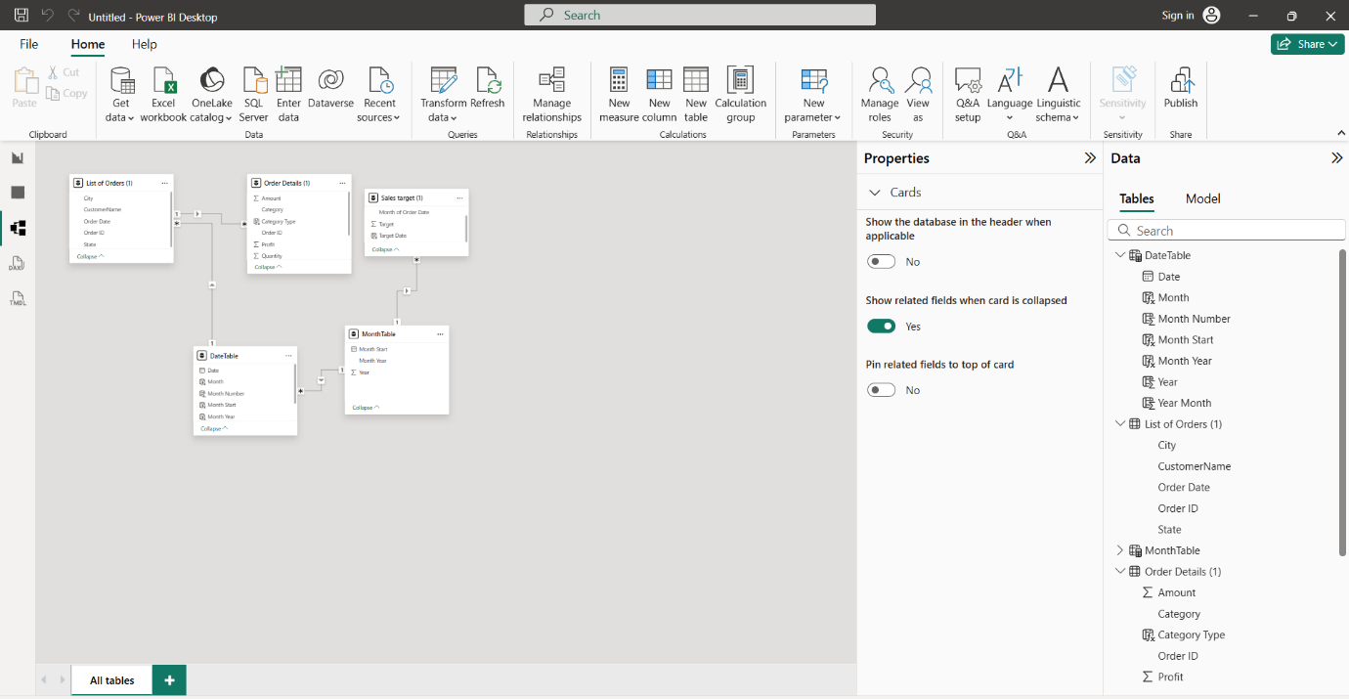
Figure 1: Data model showing the relationships between the order, order details, date, month and sales target tables.

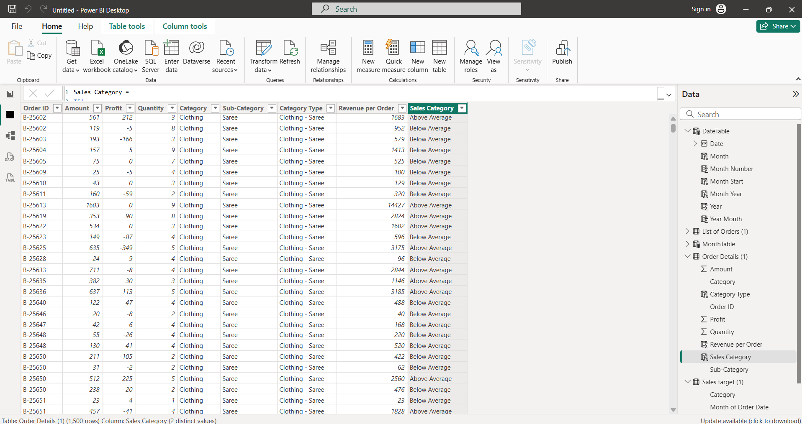
Figure 2: Calculated columns created in the Order Details table using DAX.

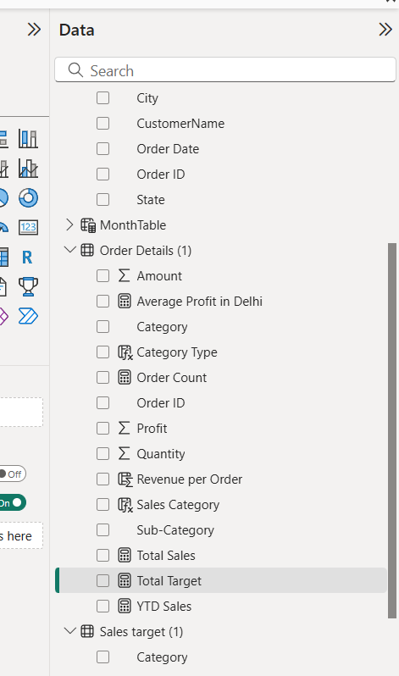
Figure 3: DAX measures created for Order Count, Average Profit in Delhi, Total Sales, Total Target and YTD Sales.

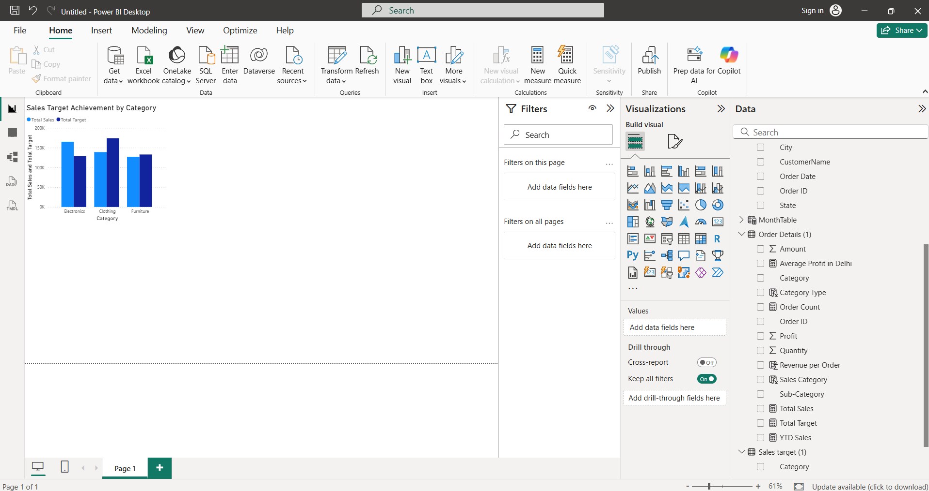
Figure 4: Clustered column chart comparing actual sales with sales targets across product categories.

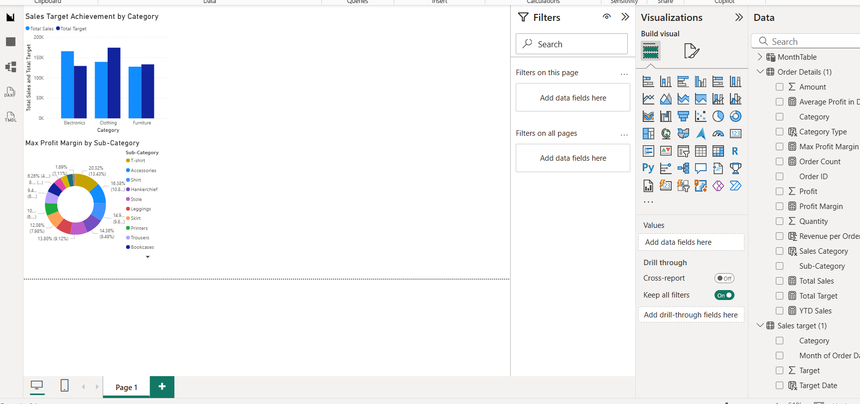
Figure 5: Donut chart showing maximum profit margin across product sub-categories.

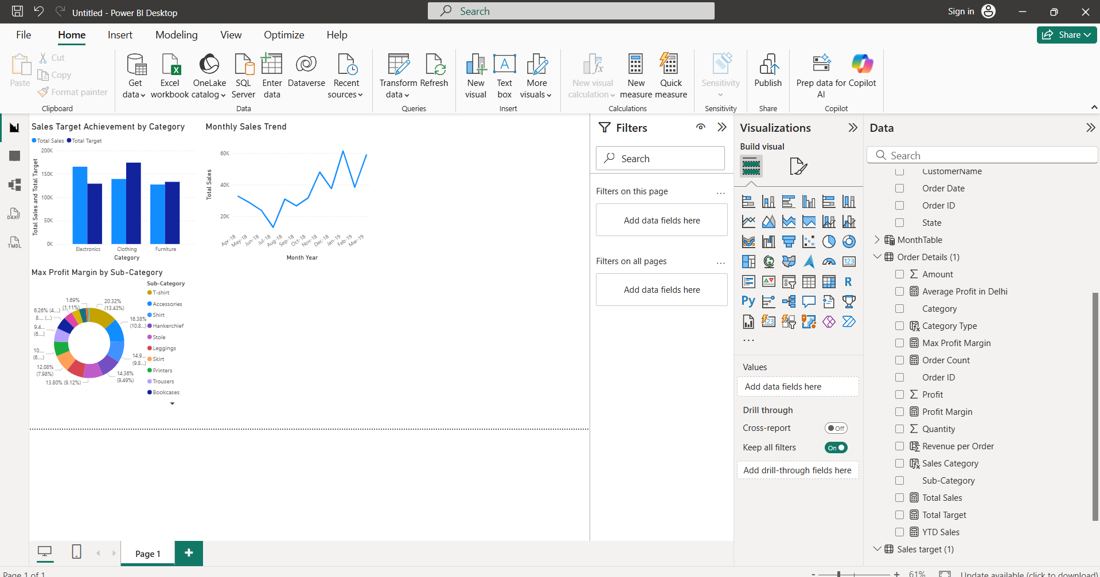
Figure 6: Line chart showing the monthly sales trend over time.

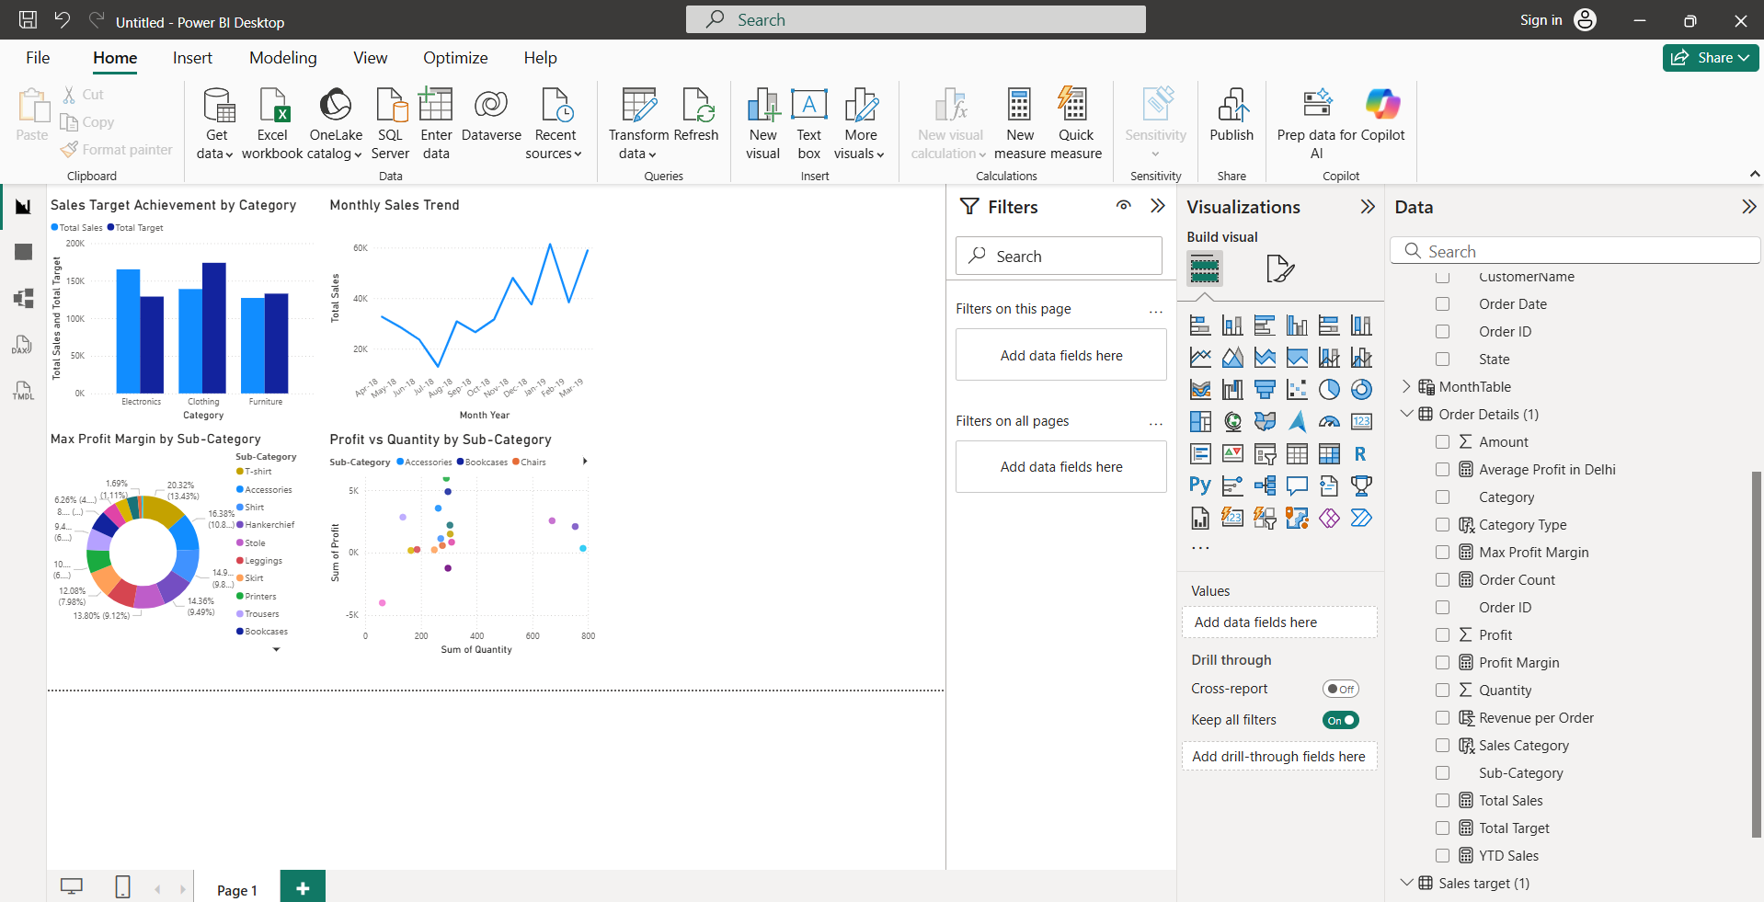
Figure 7: Scatter chart comparing profit and quantity sold across product sub-categories.

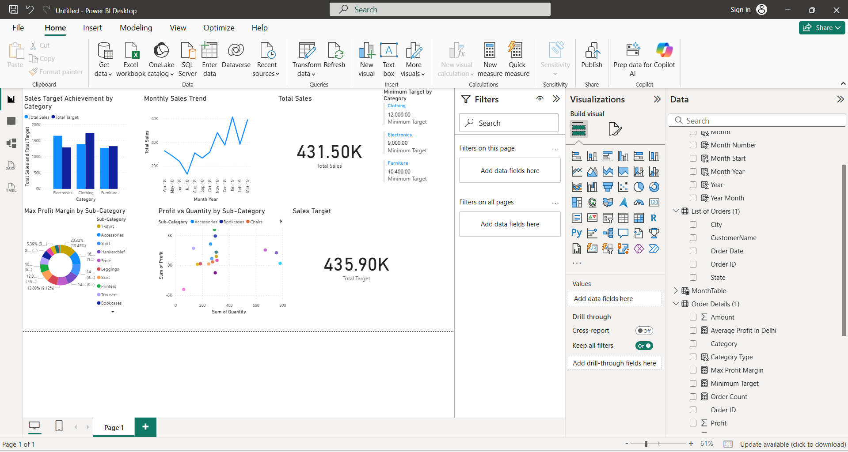
Figure 8: Card visuals displaying total sales, total sales target and minimum target by category.

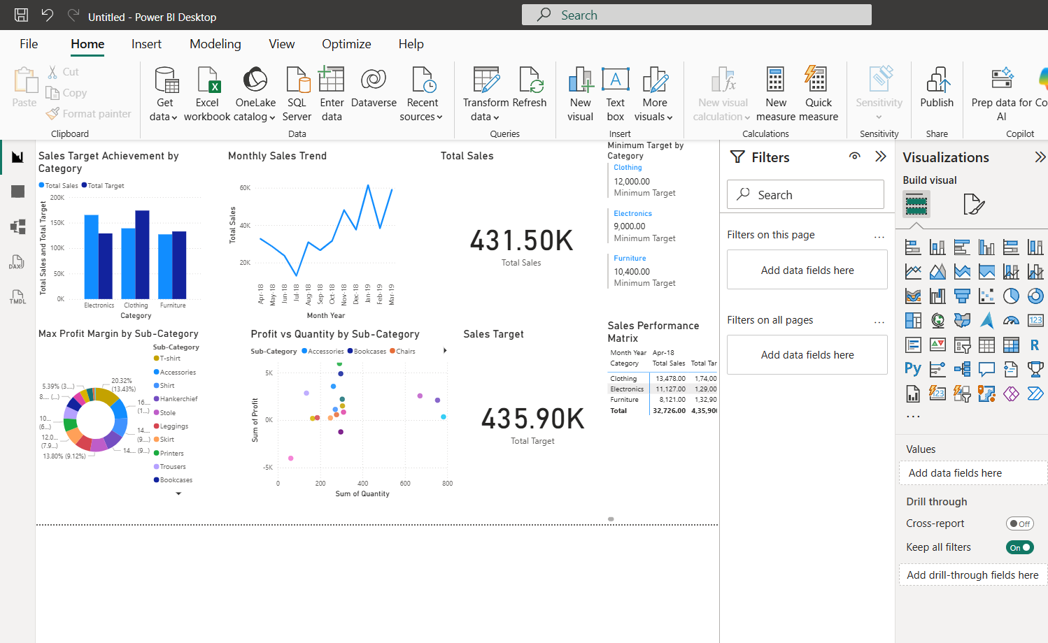
Figure 9: Sales performance matrix comparing actual sales and sales targets across categories and months.

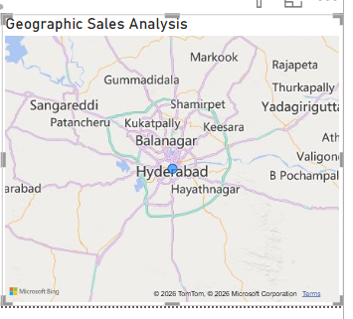
Figure 10: Geographic sales analysis showing total sales by city.

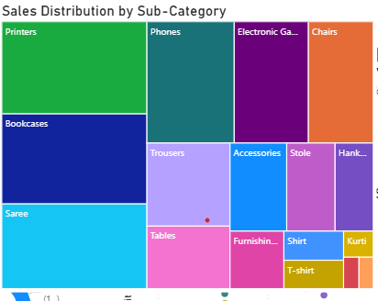
Figure 11: Treemap showing sales distribution across product sub-categories.

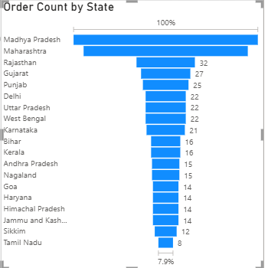
Figure 12: Funnel chart showing order count distribution across states.

